Chapter 1: Interactive System Design
William Newman
October 3, 2003

Copyright © 2003, William Newman

Design is an activity we all engage in, for it is our way of choosing courses of action that achieve what we want. A simple example is choosing a route from A to B: what we want may be to get there quickly, or to go past someone’s house – or not to go past someone else’s house. A simpler example still is found in the context of medical consultations: the patient, when the doctor examines an area of soreness, emits a grunt or ‘pain cry’ designed to help the doctor identify the point of pain without distracting him/her from the task. As these examples of “naïve design” illustrate, we can design very quickly something whose consequences may last for a long time.

So all of us are designers. But some of us are more than that: we are Designers who do design in the furtherance of making a living. We tackle design problems that take more than a minute or two to solve, and whose consequences affect many people. The things we design have potential value to these people, or at least that is the hope. That way, money may change hands and some of it may eventually reach us, the designers.

Are professional design and naïve design fundamentally different? Ultimately they are not; for all design is about achieving desired outcomes through courses of action. But professional design is far more complex. It concerns things that may be difficult and expensive to produce, such as Formula 1 cars. It may concern things that have never been designed before, such as a space station. These things, once designed and built, need to work as intended; otherwise huge financial losses may occur, even loss of life. The complexity of the design process brings with it many opportunity for things to go wrong.

Fortunately, the fundamental similarity of all design activities comes to our rescue. It enables us to apply the principles of naïve design to professional design. So what are these principles?

Principles of Design
One of the great authorities on problem solving, including the activities of designers, was Herbert A. Simon (1915-2001). His book The Sciences of the Artificial explores the nature of design, starting with the following definition:

Everyone designs who devises courses of action aimed at turning existing situations into preferred ones.

Simon proceeds to identify what we can consider the essential elements of design:

- its goal of achieving satisfactory rather than optimal solutions – of satisficing;
- its concern with finding alternative solutions so as to choose between them;
- its reliance on hierarchic subdivision of the problem;
- its dependence on representations;
- its use of simulations to make predictions of outcomes.

Simon also draws our attention to the existence of two environments at play in designing technologies. These are the outer environment into which the designed technology will be introduced, and the inner environment of the technology itself. Success as a designer depends crucially on knowledge of these two environments. There are many examples, failures as well as successes, that illustrate this point.

What system designers do
To see how Simon’s principles fit the activities of system designers, we need to look at the results of studies of what these people do. One of the earliest and most insightful was a study of novice and expert software designers by Adelson and Soloway. They set designers of both kinds a number of simple design exercises, encouraging them to “think aloud” as they worked. The following behaviours were observed in all designers:

- Formation of mental models. Designers formed an internal working model of the design-in-progress, capable of supporting mental simulations (see below). Evidence of these models was seen in the block diagrams and other sketches drawn of the design-in-progress.
- Systematic expansion of mental models. They gradually transformed an abstract mental model into a concrete one, by expanding it and replacing parts of it with concrete components.
- Simulation of mental models. Often with the aid of sketches, designers took the design-in-progress through a sequence of steps and reflected on the results.
- Representing constraints. Designers from time to time assert properties and constraints to which the design-in-progress must adhere.

We can see some overlap between the general principles offered by Simon and the observed behaviours seen by Adelson and Soloway.

To gain an overall picture of what is happening here, we can draw on the writings of D. T. Campbell, particularly his model of creative thought as blind variation and selective retention. He invites us to think of designers – and others who think creatively – as working ‘blind’, able to see only known solutions, none of which may satisfy the problem at hand (Figure 1). To make progress they must adopt one of these solutions and vary it, thus stepping out into unfamiliar territory. They then test the result and either reject or retain it on this basis. If they retain it, in effect they have pushed back the boundary surrounding known solutions. | 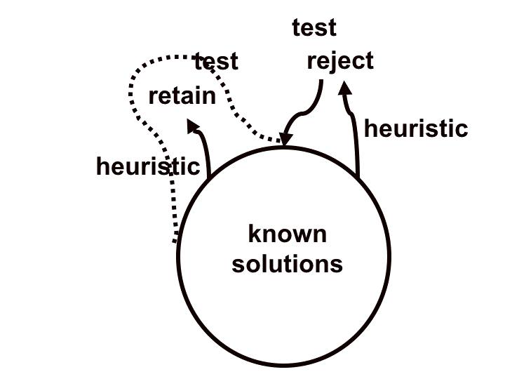  Figure 1. Campbell’s Blind Variation and Selective Retention model.

Campbell’s model nicely incorporates several of Simon’s concepts and also offers a model of what Adelson and Soloway’s designers were doing. In effect, they were drawing a mental model from their store of known solutions, and systematically expanding this model by varying and simulating the model’s components. One question remains: on what basis are variations chosen? For this purpose I have introduced to the model the use of heuristics – guidelines and rules of thumb that suggest a variation to the designer, e.g., “reducing the number of parts results in greater reliability.” On this basis the designer might vary the design-in-progress by combining two components into one. However, the subsequent simulation might expose a problem, and the variation would have to be discarded.

How Does This Relate to Interactive Systems?
We are now in a position to overlay these models of design onto the activity of interest to us – interactive system design.

- Representing constraints. These may take the form of requirements, or conditions imposed by our inner and outer environments – the software platform we’re using or the context of in which the system will be used.
- Adoption of a mental model. We are likely to adopt a familiar overall ‘architecture’ for our design; this might be a Word-style text editor, or a particular style of web page such as a search engine display.
- Simulation and testing of the mental model. We may apply a walk-through style of testing, looking for possible user problems at each step in the simulation.
- Systematic expansion of the mental model with the aid of heuristics. Unsatisfactory aspects of the model will almost certainly be exposed by early simulations, focusing our attention on certain components of the design. Depending on the nature of the problem, we can apply a relevant heuristic; for example, if users frequently use a command that is inappropriate for the context, we can adopt the strategy of hiding or greying-out invalid commands.

In the course of this and subsequent lectures we will have opportunities to observe these design activities.

References
Adelson B. and Soloway E. (1985) “The Role of Domain Experience in Software Design.” IEEE Trans. on Software Engineering, Vol SE-11, no. 11 (November 1985), pp. 1351-1360.
Campbell, D. T. (1960) “Blind Variation and Selective Retention in Creative Thought as in Other Knowledge Processes.” Psychological Review, Vol. 67, no. 6, pp. 380-400.
Simon H. A. (1969) The Sciences of the Artificial. Cambridge MA: MIT Press. See in particular Chapter 5, “The Sciences of Design: Creating the Artificial.”

